Multi-point measurement that’s MID compliant – now available from Socomec
City, Date xx^{th}, 2023

DIRIS Digiware: first multi-circuit measurement system now suitable for billing & sub-billing applications!
Integrated power specialist, Socomec, announces that its industry-leading DIRIS Digiware is now available as a MID (Measuring Instrument Directive) compliant version suitable for billing and sub-billing applications.
All meters installed in applications that require billing and sub-billing according to actual energy consumed must comply with the Measuring Instrument Directive (MID) in Europe. This applies to residential, commercial and light industrial billing, for example, as well as sub-billing applications such as co-located data centres or stores within malls or airports.
The proven DIRIS Digiware I-30, I-35, I-60, I-61, S-130 and S-135 current measurement modules are now available as a MID version, making the DIRIS Digiware system the first multi-point measurement system on the market to be suitable for billing and sub-billing applications.

Ensuring a high level of metrological security

The Measuring Instrument Directive is an EU directive of the European Parliament and Council of
26 February 2014 (2014/32/EU) that applies to measuring instruments such as water, gas, electrical energy, thermal energy, as well as weights or quantities of liquids meters used in commercial transactions. A specific annexe of the directive (MI-003) is dedicated to active electrical energy meters (kWh).

The MID sets out a legal framework to ensure consumer protection and fair trading, stipulating that measuring instruments must be assessed via a notified body. The design and manufacture of a MID certified measuring instrument must be of a high standard for metrology and measurement data security – but the main objective of MID is to ensure that all parties involved have confidence in the measurement result.

[NAME], [TITLE], Socomec comments; “Conformity assessments of measuring instruments are carried out by a notified body. Electricity meters, for example, might typically be evaluated in terms of product design and production process quality assurance.
“EN 50470-1 and EN 50470-3 provide a presumption of conformity to the MID. They define the requirements in terms of mechanics, electromagnetic compatibility and accuracy. A product designed in accordance with these standards will meet the essential and specific requirements of the MID. The notified body uses these standards and the directive to verify the conformity of the meters. The accuracy of the active energy measured by the meter is defined as Class A, B or C.”

MID certified measuring instruments that set a new industry standard

Socomec provides a range of MID certified measuring instruments where metering is carried out either
as a direct connection or through current sensors or transformers.
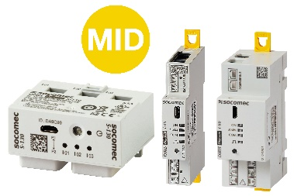
These include traditional meters in a modular format – COUNTIS – that allow the measurement of active energy from one load. In addition, DIRIS Digiware S-13xMID, I-3xMID and I-6xMID meters are Class C certified meters, ideally suited to accurately measure the consumption of multiple electrical loads. A single display simplifies the reading of all measurements.

To ensure system integrity and unprecedented measurement accuracy, DIRIS Digiware MID energy measurement modules are equipped with innovative features that go beyond conventional market practice.

[NAME] continues; “We understand how crucial it is that these measurements are accurate – and that all parties have complete trust in the integrity of the data. Our DIRIS Digiware MID modules incorporate really innovative tamper-proof devices, comprising an intelligent alarm system that is more effective than the conventional seals offered by traditional MID meters.”
DIRIS Digiware MID current measurement modules have a measurement accuracy of class C according to the MID directive, which is the most accurate class.
To learn more – and to benefit from Socomec’s unique, MID compliant DIRIS Digiware S-13xMID, I-3xMID and I-6xMID meters which are part of the Digiware ecosystem (INSERT CTA : article web).

SOCOMEC: When energy matters |  | Press contact
Founded in 1922, SOCOMEC is an independent industrial group with a workforce of 3900 experts spread over 30 subsidiaries in the world. Our core business: the availability, control and safety of low voltage electrical networks serving our customers’ power performance. In 2023, SOCOMEC posted a turnover of 725* M€ turnover  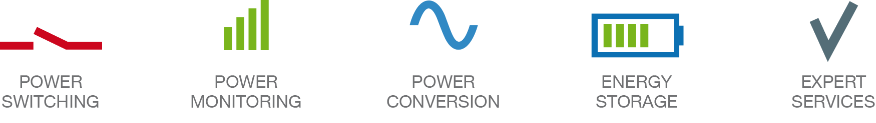 |  | Firstname Lastname  Function  Phone number  Mobile Number  xxxxxxxx@socomec.com  www.socomec.co.uk

